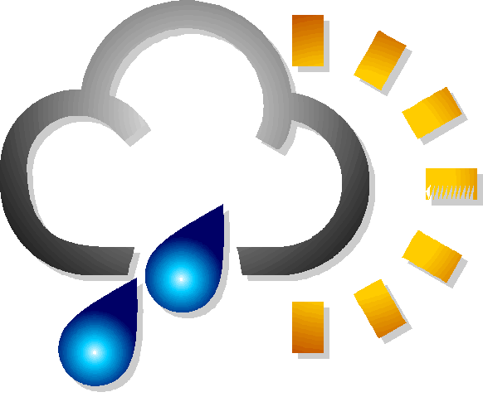
Name ___________________________

Class ___________________________

Date Completed __________________
Weather on the Web
Time Completed __________________

Go to http://www.tvja.org/science/weather.htm on the Internet to complete these questions. Begin each question from the TVJA Weather page. Use additional paper if need.

- Click on TVJA's Weather Station: Current Conditions. What is the current temperature? _________ Is the temperature rising or falling? _______ What was the maximum wind speed recorded today? ________________

- Click on TVJA’s Weather Station on WeatherBug. Click on change tracking station. Then select a weather station in another state. Where is the weather station located? _____________________________ What is their current temperature? ___________ What was their highest and lowest temperature today? ________ High ________ Low

- Click on DataStream. Go down to Surface and click on Isobars, Fronts, Radar & Data. On the weather map find the weather station for Portland, OR. Draw the symbol and accompanying data for Portland's weather station in the box below. Using this weather map information fill in the correct data as indicated on the lines next to the box. (You will need to print or enlarge the map to read it. Go back and scroll down on the DataStreme page and click on Weather Map Symbols or turn to page 103 in your textbook for help with the symbols. Don’t get the symbol confused with the WA/OR state border)

Temperature _______________________________
Dew Point _________________________________
Barometric Pressure _________________________
Wind Direction _____________________________
Wind Speed _______________________________
Cloud Cover _______________________________
Is there a High or Low pressure area affecting Portland? __________________________________

- At the DataStreme site, scroll down to Satellite. Select Infrared - Latest. Where are the clouds in relationship to the fronts and radar echoes seen on the weather map in question #3? (This may be easier to answer if you print the weather map from question #3 to compare it to the satellite image.) ___________________________________________________________
____________________________________________________________________________________________________________________________________________________________________________________________________________________________________________

5. Under General Weather Topics, click on DataStreme Junction. Find and select the link for The National Hurricane Center. Find and select the Atlantic Season Summaries and Reports for the most recent month. Name a hurricane that had maximum winds greater than 100 mph. _________________ What was it’s maximum wind speed? __________ How many people died in this hurricane? __________________________
6. Click on NOAA. What Active Weather Warnings are currently being displayed? _________________________________________________
___________________________________________________________
___________________________________________________________
___________________________________________________________
___________________________________________________________
Is Oregon on the warning list? ______ If so, click on Oregon and describe the warning. ________________________________________________
___________________________________________________________
___________________________________________________________
___________________________________________________________

- Click on NOAA (Portland). Find and select Snow Data on the left side bar. Scroll down and click on Mount Hood/Meadows. Does it indicate a total snowdepth? ______ If so, what is it? ______ What is the strongest wind recorded in the last 24 hours on the mountain? ________ Go back to NOAA (Portland) and select AHPS Rivers/Lakes on the side bar. Scroll down and select Tualatin River (and Tributaries) and click on at Rood Bridge near Hillsboro. What is the current river stage in feet? ______________ Why is it important to monitor river levels? __________
___________________________________________________________
___________________________________________________________

- Click on Science Explorer. Find and select Chapter 3: Weather Patterns. Select the Self-Test and complete the test. Print your answer/score sheet and staple it to this sheet. For 25 extra credit points complete the Internet Activities for Ch. 3 also at this site and turn in your report when complete.

- Enter your zip code in The Weather Channel cell. On this web site how many days in advance can you find forecast information? ______ Find and click on World Weather at the top of the page. List the country you selected: ___________________ List the city you selected in that country: _______________________________ What are the current weather conditions at this location? _____________________________________ ____________________________________________________________________________________________________________________________________________________________________________________________________________________________________________

- Click on Intellicast. Find Global Weather Maps and select Satellite. What did you find on this page? ____________________ How might this be useful? ____________________________________________________

- Find and select Geostationary Satellite Server. What are the three types of satellite images found here? _______________ _______________ _______________ Compare and contrast the differences between Visible, InfraRed (IR) and Water Vapor satellite images. ___________________ ___________________________________________________________
___________________________________________________________
___________________________________________________________
___________________________________________________________
___________________________________________________________
(For more information on satellites click on the Remote Sensing link under Predicting Weather on the TVJA Weather page.)

