Native Plant Collection Grade Sheet Name ___________________________________________
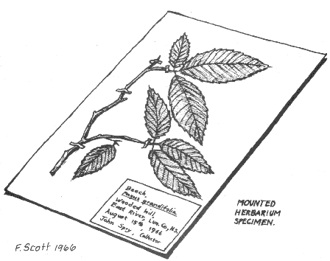
30 + Specimens Identified & Labeled Biology Lab
Herbarium of Tualatin Valley Junior Academy

Scientific Name __________________________
Common Name __________________________
Location ________________________________
County ___________________ State _________
Habitat _________________________________
Date ___________________________________
Name of Collector ________________________

*In a scientific name the genus is always capitalized and the species is always lower case. Example: Acer macrophyllum
½ point subtracted when this system is not followed.

# | Scientific Name | Common Name | Location | County | Habitat | Date | Collector | Specimen Quality (+ / -) | Duplicate Specimen (-) | Unidentified Specimen (-) | Total Points ( /10)
1
2
3
4
5
6
7
8
9
10
11
12
13
14
15
16
17
18
19
20
21
22
23
24
25
26
27
28
29
30
E.C.
Grand Total __________
300

